Project Planning Phase
Project Planning Template (Product Backlog, Sprint Planning, Stories, Story points)

Date | 05-07-2026
Team ID
Project Name | ONLINE COMPLAINT REGISTRATION
Maximum Marks | 5 Marks

Product Backlog, Sprint Schedule, and Estimation (4 Marks)
Use the below template to create product backlog and sprint schedule
Sprint | Functional Requirement (Epic) | User Story Number | User Story / Task | Story Points | Priority | Team Members
Sprint-1 | User Registration | USN-1 | As a user, I can register an account with name, email, phone, password, and role | 3 | High | B.V.Rajya Lakshmi
Sprint-1 | User Login | USN-2 | As a user, I can securely log into the application using my email and password. | 2 | High | B.V.Rajya Lakshmi
Sprint-1 | Forgot Password | USN-3 | As a user, I can reset my password using my registered email address. | 2 | High | B.V.Rajya Lakshmi
Sprint-1 | User Profile | USN-4 | As a user, I can view and update my profile details | 2 | Medium | B.V.Rajya Lakshmi
Sprint-2 | Complaint Registration | USN-5 | As a user, I can submit a complaint with category, description, and supporting image. | 5 | High | B.V.Rajya Lakshmi
Sprint-2 | Complaint Tracking | USN-6 | As a user, I can track the current status of my complaint | 3 | High | B.V.Rajya Lakshmi
Sprint-2 | Complaint Cancellation | USN-7 | As a user, I can cancel my complaint before it is resolved. | 2 | Medium | B.V.Rajya Lakshmi
Sprint-3 | Agent Management | USN-8 | As an admin, I can create and approve agent accounts. | 3 | High | B.V.Rajya Lakshmi
Sprint-3 | Complaint Assignment | USN-9 | As an admin, I can assign complaints to available agents. | 4 | High | B.V.Rajya Lakshmi
Sprint-3 | Dashboard | USN-10 | As an admin, I can monitor complaints through dashboard charts and statistics. | 3 | High | B.V.Rajya Lakshmi
Sprint-4 | Complaint Resolution | USN-11 | As an agent, I can update complaint status and upload a resolution image. | 4 | High | B.V.Rajya Lakshmi
Sprint-4 | Chat Module | USN-12 | As a user and agent, I can communicate through the chat system. | 4 | Medium | B.V.Rajya Lakshmi
Sprint-4 | Feedback | USN-13 | As a user, I can submit feedback after complaint resolution. | 2 | Medium | B.V.Rajya Lakshmi
Sprint-4 | Responsive Design | USN-14 | As a user, I can use the application on mobile, tablet, laptop, and desktop devices. | 3 | High | B.V.Rajya Lakshmi

Project Tracker, Velocity & Burndown Chart: (4 Marks)
Sprint | Total Story Points | Duration | Sprint Start Date | Sprint End Date (Planned) | Story Points Completed (as on Planned End Date) | Sprint Release Date (Actual)
Sprint-1 | 20 | 3 Days | 01 Jul 2026 | 03 Jul 2026 | 20 | 03 Jul 2026
Sprint-2 | 20 | 3 Days | 04 Jul 2026 | 06 Jul 2026 | 20 | 06 Jul 2026
Sprint-3 | 20 | 3 Days | 07 Jul 2026 | 09 Jul 2026 | 20 | 09 Jul 2026
Sprint-4(Testing and Bug fixes) | 20 | 3 Days | 10 Jul 2026 | 12 Jul 2026 | 20 | 12 Jul 2026

Velocity:
Imagine we have a 10-day sprint duration, and the velocity of the team is 20 (points per sprint). Let’s calculate the team’s average velocity (AV) per iteration unit (story points per day)

Total Story Points = 80
Total Sprint Duration = 12 Days
Average Velocity:
80 ÷ 12 = 6.67 Story Points per Day
You can write:
Average Velocity = 6.67 Story Points/Day

Burndown Chart:
A burn down chart is a graphical representation of work left to do versus time. It is often used in agile software development methodologies such as Scrum. However, burn down charts can be applied to any project containing measurable progress over time.

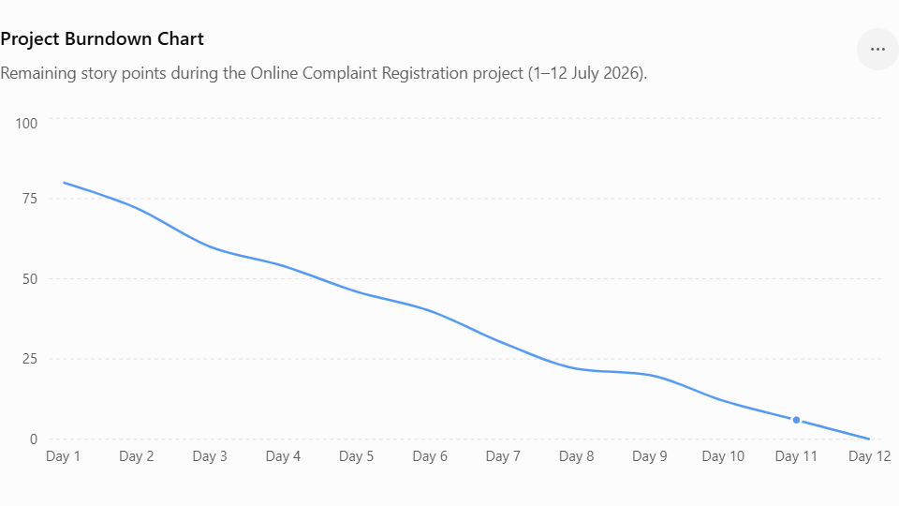

References:

https://www.visual-paradigm.com/scrum/scrum-burndown-chart/
https://www.atlassian.com/agile/tutorials/burndown-charts

Reference:
https://www.atlassian.com/agile/project-management
https://www.atlassian.com/agile/tutorials/how-to-do-scrum-with-jira-software
https://www.atlassian.com/agile/tutorials/epics
https://www.atlassian.com/agile/tutorials/sprints
https://www.atlassian.com/agile/project-management/estimation
https://www.atlassian.com/agile/tutorials/burndown-charts

